Step one - Rough top of umbrella
Example: I help florists get more sales

Step 2: Research your potential niche
1: Follow the system to build a dummy channel
2: Use the search bar and just type the problem you solve to find channels
3: Establish the views ceiling
4. Fill out the pattern bank
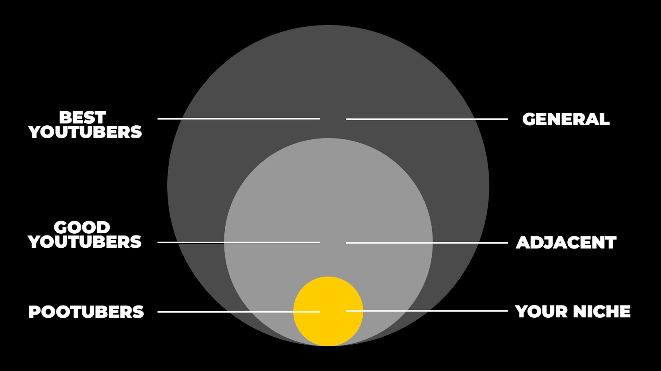
If you niche sucks or seems none existent, all we really need to know is:
- What topics seem most in demand
- What things appear in thumbnails
- What titles might do well
- What are the patterns that always appear (there's usually 3-5 in each niche)
Don't panic if your niche sucks, We just need to understand what your avatars are interested in.
I hardly ever got inspiration from my niche. I just went “ok graphs going up, social hacking, views doing up and down and editing timelines” that was it.
We’re not looking for the exact channel you want to be, if you don't find that it makes no difference because the next 2 steps are where the best titles tend to come from.
This is where you win, you learn to play the YouTube game whilst the PooTubers keep.
NOTE: Some of you might be in a niche full of talent, it makes no difference, we do the same thing.
You might also find you have all the inspiration you need and a tonne in your pattern bank, you might find you have no channels dedicated to your niche only a few videos with decent views, thats ok)
Step 3: Research your adjacent niche
1: Finding adjacent niches/channels
An adjacent niche is one that covers problems you could do or very similar ones.
To work out your adjacent niche ask yourself: What are the core problems my audience faces that I help solve?
As a channel about growing a florist business our niche isn't flower arranging, its business. We will never position a video about “how to make roses look amazing” thats a different niche/avatar/problem
So our problems are:
1. Sales
2. Marketing
3. Getting more weddings/funerals
4. Social media
5. Managing a team
- Search “how to generate more sales”
- Click the first one that feels relevant , look at the channel? Anything we could steal?
- Look for repeating patterns that can relate (items, icons, text,)
- Think about your avatar, Hormozi appeals to men, we’re not going after the Bros, so we need to soften the approach
- You don't need 100s of channels, if you make this too big you will overwhelm yourself. Really we just need 4 interesting thumbnails and titles to start working on based on patterns from your niche and interesting packaging from outside
Here’s my adjacent titles I like and how they could be applied
Step 4: Research YouTube
Where do the top creators get their ideas who want to lead the niche?
- They don't copy the smaller channels, they copy the random ones.
- 1of 10: This is where a tool like 1of10 is very effective
- Find some titles you like + add them to your bank (they need to appeal to your avatar)
Step 5: Construct some titles based on outliers/patterns
- We can use a title from a general channel and apply the patterns from your niche
- The more specific the less views, unless the problem is massive
- Get feedback
Step 6: Doodle your thumbnails
- The trick is to create curiosity + give context to your niche + keep it simple
- Get feedback k
Step 7: Make thumbnails
Step 8: Plan your content, make your video

